# Tutorial : Asset Diversification

This document is set as follows: a brief introduction to the notion of diversification in Finance, the description of the Markowitz Model for a portfolio of risky assets and the calculations associated. Finally, an exercise will help to demonstrate how the Markowitz Model works.

## Asset diversification

**Diversification**

The diversification is a technique that aims to reduce the global risk of a portfolio by spreading money among various investments.

The theory behind that technique is that a well-diversified portfolio tends to have a higher yield and to pose less risky than any investment within the portfolio taken individually. Indeed, the diversification enables the positive performance of some investments in the portfolio to compensate the negative performance of others.

The diversification benefits the investors when the different assets within the portfolio are not perfectly correlated or are negatively correlated. For example let’s imagine a portfolio composed of US and European Stocks. A downturn in the US economy may not affect the European economy in the same way and thus the European stocks may limit the losses of the US ones.

In the end, the diversification technique’s objective is to limit the fluctuation of investment returns without sacrificing to much potential gain.

## Markowitz Model

The Markowitz Model also called the modern portfolio theory (MPT), is a portfolio-selection technique developed by Henry Markowitz between 1952 and 1959. This technique demonstrates that investors should focus on the overall risk and return as criteria for the selection of a portfolio. By analysing the risk-reward profiles of several portfolios, the MPT enables the investors to choose a portfolio with a maximized expected return for a given amount of risk.

Now we will see how to calculate the portfolio’s expected return and risk, the concept of efficient frontier and how to find the minimum variance portfolio.

**Portfolio’s Expected Return:**

It’s the amount, an investor would anticipate receiving from his portfolio by the end of the time horizon.

The formula of the expected return for a portfolio containing n risky assets is the following:

$$E\left(r_{p}\right)=\sum_{i=1}^{n}{w_{i}E(r_{i})}$$

Where:

$E\left(r_{p}\right)$ is the expected return of the portfolio,

$E(r_{i})$ is the expected return of asset i,

$w_{i}$ is the proportion of asset i in the portfolio,

and $\sum_{i=1}^{n}{w_{i}=1}$. (no short-selling)

Example:

John has a portfolio composed of 4 different assets. Each asset’s expected return and proportion in John’s portfolio are given by the following table:

|  |  |  |  |  |
| --- | --- | --- | --- | --- |
| Assets: | Asset 1 | Asset 2 | Asset 3 | Asset 4 |
| E(r) | 3% | 6% | 5% | 10% |
| weight | 20% | 45% | 15% | 20% |

The expected return of John’s portfolio can then be calculated as follows:

$$E\left(r_{p}\right)=0.03*0.2+0.06*0.45+0.05*0.15+0.1*O.2=0.0605=6.05\%$$

**Portfolio’s Risk**

The risk is the chance that the actual return of the portfolio is different from the one expected.

The risk of a portfolio is measured by its standard deviation which is the squared root of the variance. The variance of a portfolio containing n risky assets can be obtained with the following formula:

$$Var\left(r_{p}\right)=σ_{p}^{2}=\sum_{i=1}^{n}{\sum_{j=1}^{n}{w_{i}w_{j}Cov(r_{i},r_{j})}}$$

Where:

$σ_{p}$ is the standard deviation of the portfolio,

$w_{i}, w_{j}$ are the proportions respectively of asset i and asset j in the portfolio,

$r_{i},r_{j}$ are the rates of return respectively of asset i and asset j,

$Cov\left(r_{i},r_{j}\right)$ measures how much $r_{i}$ and $r_{j}$ change together

Note :

$$Cov\left(r_{i},r_{j}\right)=ρ_{ij}σ_{i}σ_{j}$$

Where :

And $σ_{i}, σ_{j}$ are the standard deviation of $r_{i}$ and $r_{j}$,

$ρ_{ij}$ is the correlation coefficient between the rates of return of the assets i and j,

With $-1≤ρ_{ij}≤1$, $ρ_{ij}=ρ_{ji}$ and $ρ_{ii}=1$.

Example:

Julia has the following portfolio:

|  |  |  |  |
| --- | --- | --- | --- |
| Assets: | Asset 1 | Asset 2 | Asset 3 |
| $$σ$$ | 7% | 9% | 4% |
| weight | 30% | 20% | 50% |

The correlation coefficients between the rates of return of the different assets are the following:

$ρ_{12}=0.45$, $ρ_{13}=-0.20$, $ρ_{23}=0.15$

We can then calculate the portfolio’s standard deviation:

9)𝑑 then calculate:re the following:rates of return of the assets 1 and 2 is :

**Markowitz Efficient Frontier**

Let’s plot in a risk-return space all the possible combination of two given assets. The line in this space represents all the existing portfolios composed of these two assets.

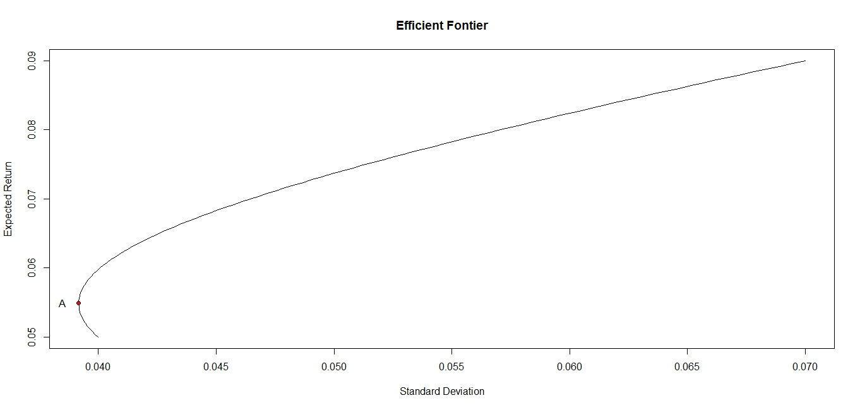

As we can observe all the portfolios located on the segment below the point A aren’t interesting for investors as for the same amount of risk we can find portfolios with a higher expected return on the segment above the point A. That last segment is called the efficient frontier, all portfolios on that line have the best possible return for a given amount of risk (standard deviation). The point A is called the Minimum Variance Portfolio, it’s the combination of the two assets that offers the lowest standard deviation (risk).

Note :

Now we plot the same graph as previously but for different values of the correlation coefficient (Rho).

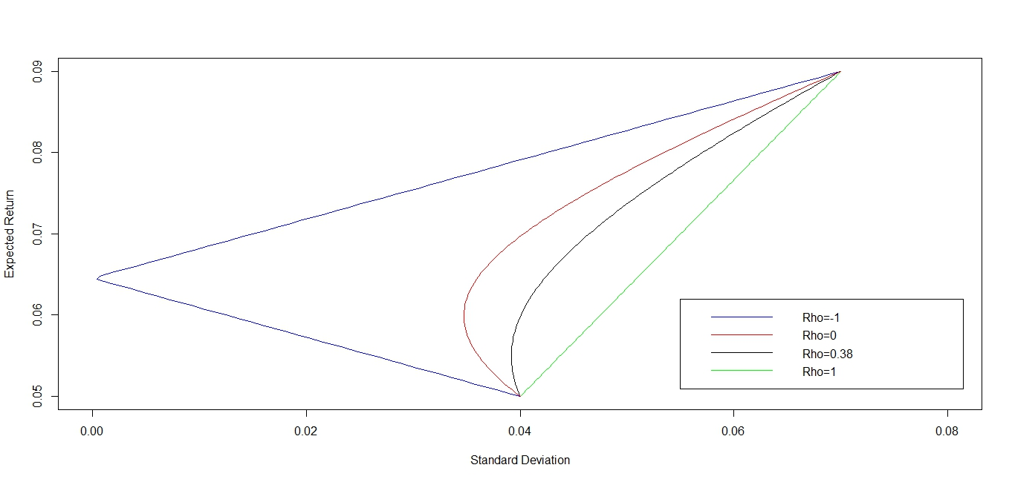

We can then observe that when Rho < 0 the diversification benefits a lot to the investor as the risk drastically diminishes whereas it's the opposite when Rho is close to 1.

**Minimum Variance Portfolio**

Calculating the minimum variance portfolio (MVP) corresponds to finding the weight of each asset so that the portfolio’s variance is the lowest.

Case of a two-risky-assets portfolio:

Let’s suppose we have the following portfolio:

|  |  |  |
| --- | --- | --- |
| Assets | Asset 1 | Assets 2 |
| $$σ$$ | $$σ_{1}$$ | $$σ_{2}$$ |
| weight | $$w_{1}$$ | $$w_{2}$$ |

With $ρ_{12}$ the correlation coefficient between the rates of return of asset 1 and asset 2.

We can find the MVP using the following formula:

$${Min σ}_{p}^{2}=\sum_{i=1}^{2}{\sum_{j=1}^{2}{w_{i}w_{j}Cov\left(r_{i},r_{j}\right)=\sum_{i=1}^{2}{\sum_{j=1}^{2}{w_{i}w_{j}ρ_{ij}σ_{i}σ_{j}}}}}$$

$${Min σ}_{p}^{2}={\left(w_{1}σ_{1}\right)}^{2}+ {\left(w_{2}σ_{2}\right)}^{2}+2ρ_{12}w_{1}w_{2}σ_{1}σ_{2}$$

With the following constraints:

$w_{1}{+w}_{2}=1$,

$$w_{1}≥0, w_{2}≥0$$

So we find:

$w_{1}=\frac{σ_{2}^{2}-ρ_{12}σ_{1}σ_{2}}{σ_{1}^{2}+σ_{2}^{2}-{2ρ}_{12}σ_{1}σ_{2}}$ and $w_{2}=1-w_{1}$

Case of a portfolio containing 3 or more risky assets:

This case is a lot more complicated than the previous one. Indeed, we have to use the Lagrangian objective function :

$$C=\sum_{i=1}^{n}{\sum_{j=1}^{n}{w_{i}w_{j}Cov(r_{i},r_{j})}}+λ_{1}[E^{*}-\sum_{i=1}^{n}{w_{i}E(r_{i})]+λ_{2}(1-\sum_{i=1}^{n}{w_{i})}}$$

Where:

$E^{*}$ is the expected return targeted by the investor,

And $λ_{1},λ_{2}$ are the Lagrange multipliers.

We won’t develop the calculation but you can find it [here](portfolio_optimization.pdf).

## Exercise

[Exercise 1 - Subject](Exercise%201%20-%20Subject.xlsx)

[Exercise 1 - Solution](Exercise%201%20-%20Solution.xlsx)

Ref :

<http://www.investopedia.com/terms/r/risk.asp>

<http://www.investopedia.com/terms/a/assetallocation.asp>

<http://www.investopedia.com/articles/02/111502.asp>

<http://www.investopedia.com/articles/basics/03/050203.asp>

<https://en.wikipedia.org/wiki/Modern_portfolio_theory>

<https://www.youtube.com/watch?v=V-I64oviqs8>